

Aesthetic Case Check List
The following are essential tools we will need to complete an aesthetic case. These should be obtained during the prep appointment and/or temp check appointment:
- All 6 requested photos (see Photo Guide below).
- Model of the pre-op.
- Impressions of the temporaries
(gingival capture is as important as capturing the margins).
- Bite registration.
- Stick-bite (horizontal plane, parallel to horizon line between pupils).
- Detailed lab prescription, thoroughly filled out.

Aesthetic Photo Guide
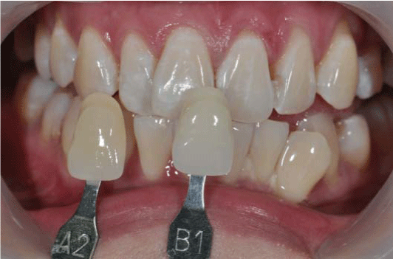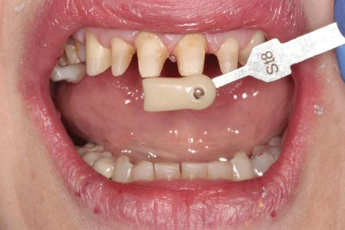
Shade Tab Stump Shade of Prepped Teeth 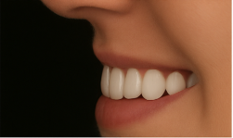 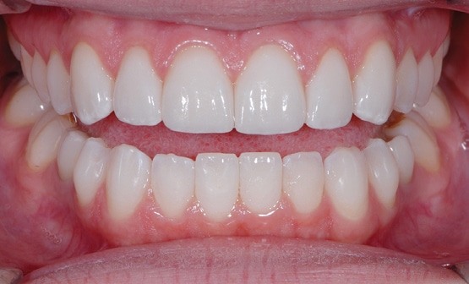
Lateral View of Temporaries Retracted Temporaries
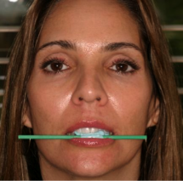
Full Face of Temporaries Stick Bite

